Aashish 210905212
ex1)counter = 100
miles = 1000.0
name = "john"
print(counter)
print(miles)
print(name)
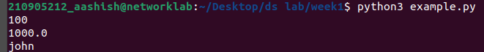
ex2)
a=b=c=1
print(a,b,c)
a,b,c=1,2,"john"
print(a,b,c)
ex3)
a=5
b=4.56
print(5*a)
print(a/2)
print(a**2)
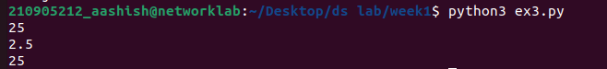
ex4)
str = "hellO woRlD"
print(str, str[0], str[2:5] , str[2:] , str * 2 , str+"test")
print("updated string:",str[:6]+'python')
print("my name is %s and height is %d cm"%('aashish',185))
print(str.capitalize())
print(str.count('l'),str.find('woRlD'),str.lower(),str.replace("woRlD","earth"),str.swapcase(),str.title())
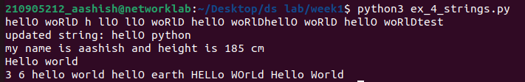
ex5)
list=['abcd',786,2.23,'john',70.2000000000000003,123,'john']
tinylist=[123,'john']
print(list,list[0],list[1:3],list[2:],tinylist*2,list+tinylist)

list2 = ['phy','chem',1997,2000]
list2.append('math')
print(list2)
del list[2]
print(list2)
print('phy' in list2)
print('eng' in list2)
print(list2.count('phy'))
list2.pop()
print(list2)
list2.insert(2,'math')
print(list2)
list2.remove('chem')
print(list2)
list2.reverse()
print(list2)
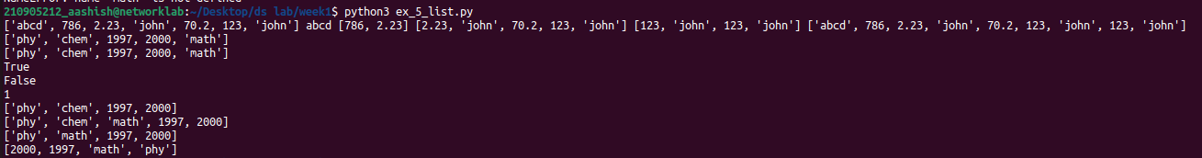
ex6)
tuple = ('abc',123,'def',456)
list = ['abc',123,'def',456]
list[1] = 124
tuple[1] = 124#not valid

solved1)
print("q1")
num = float(input('give no:'))
if num>0:
print('+ no')
elif num==0:
print('0')
else:
print('- number')

print("q2")
x=float(input('Enter a number:'))
if x<10:
print('smaller')
if x>20:
print('bigger')
print('Finished')

print("q3")
x=5
print('befor 5')
if x==5:
print('this is 5')
print('still 5')
print('after 5')
print('bfore 6')
if x==6:
print('this is 6')
print('after 6')

print("q4")
x=float(input("enter no:"))
if x<20:
print('below 20')
elif x<10:
print('below 10')
else:
print('something else')
print("q5")
x=42
if x>1:
print('above 1')
if x<100:
print('below 100')
print('done')
print("q6")
age = 15
b = ('kid' if age<18 else 'adult')
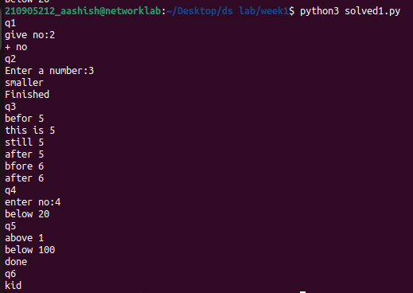
print(b)

solved2)
print("q1")
for val in [5,4,3,2,1]:
print(val)
print ('Done')

print("q2")
stud=['Ram','Vijay','Nithya','Anu','Ramesh','suja']
for k in stud:
print('Hello:', k)
print('done')

print("q3")
for i in range(5):
print(i)
if i>2:
print('Bigger than 2')
print('Done with i',i)

print("q4 Calculate factors of a number")
x=int(input('Enter a number:'))
for i in range(1,x+1):
if x%i ==0:
print(i)
x=10

print("q5: Calculate largest number in an array")
from math import *
x= [9, 41, 12, 3, 74, 15]
Largest=-inf
for i in x:
if i>Largest:
Largest=i
print(Largest)

print("Eg.6: Calculate smallest number in an array")
from math import *
x = [9, 41, 12, 3, 74, 15]
smallest=inf
for i in x:
if i<smallest:
smallest=i
print(smallest)
print("Eg.7: Calculate the count, sum and average of numerical array")
x= [9, 41, 12, 3, 74, 15]
count=su=avg=0
for i in x:
count=count+1
su=su+1
avg=su/count
print(count)
print(su)
print(avg)

print("Eg.8: Filtering in a loop (print all numbers >20)")
x= [9, 41, 12, 3, 74, 15]
for i in x:
if i>20:
print (i)

print("Eg.9: For the above problem, instead of printing the result, store the elements in a variable (object)")
x= [9, 41, 12, 3, 74, 15]
res=[]
for i in x:
if i>20:
res.append(i)

print("ex.10: For the above x, replace all elements <20 into zero. Store the result in different variable (object)")
import numpy as np
y=np.zeros(len(x))
for i in range(len(x)):
if x[i]>20:
y[i]=x[i]
print(y)

print("Eg. 11: Program using elif to check more than one condition.")
price = 100
if price > 100:
print("price is greater than 100")
elif price == 100:
print("price is 100")
elif price < 100:
print("price is less than 100")

print("Eg. 12: Program using while loop -program to display numbers from 1 to 5")
# initialize the variable
i=1
n=5
while i <= n:
print(i)
i=i+1

print("Eg. 13:Take input from user , until user enters zero and calculate the sum of entered numbers.")
total = 0
number = int(input('Enter a number: '))
while number != 0:
total += number
number = int(input('Enter a number: '))
print('total =', total)
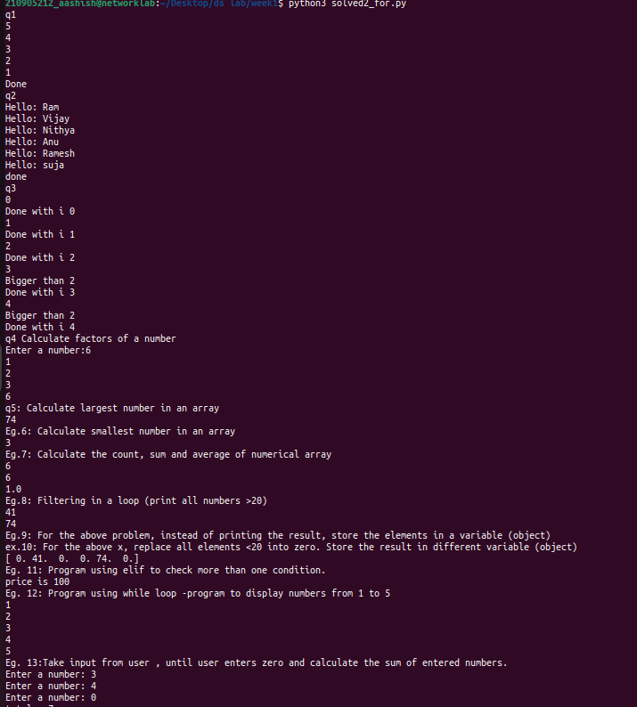
print('total =', total)

